Guide how to Run

Step 1
Open Matlab
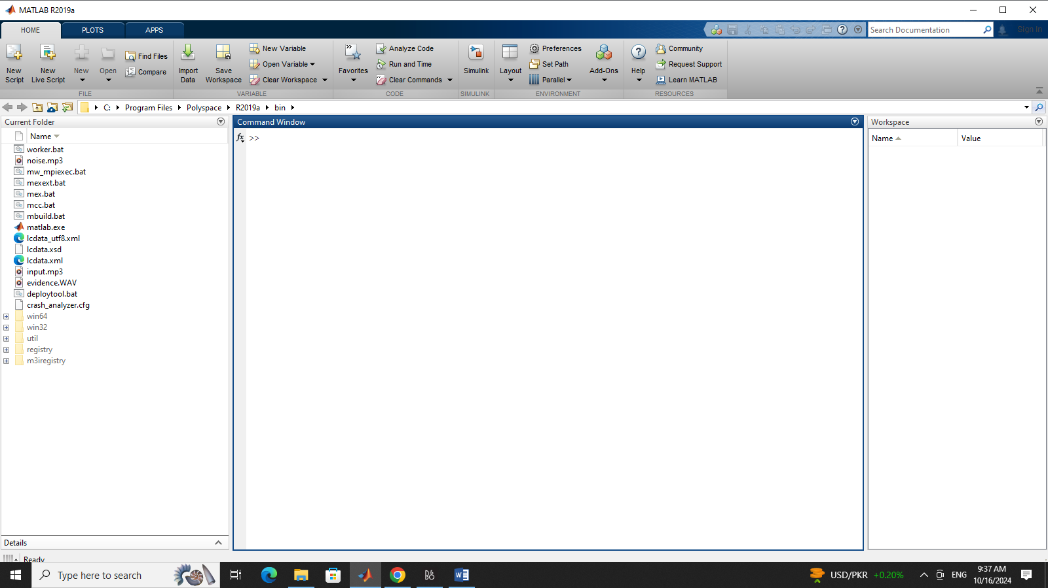

Step 2
Open matlab script in folder src with name slblocks.m
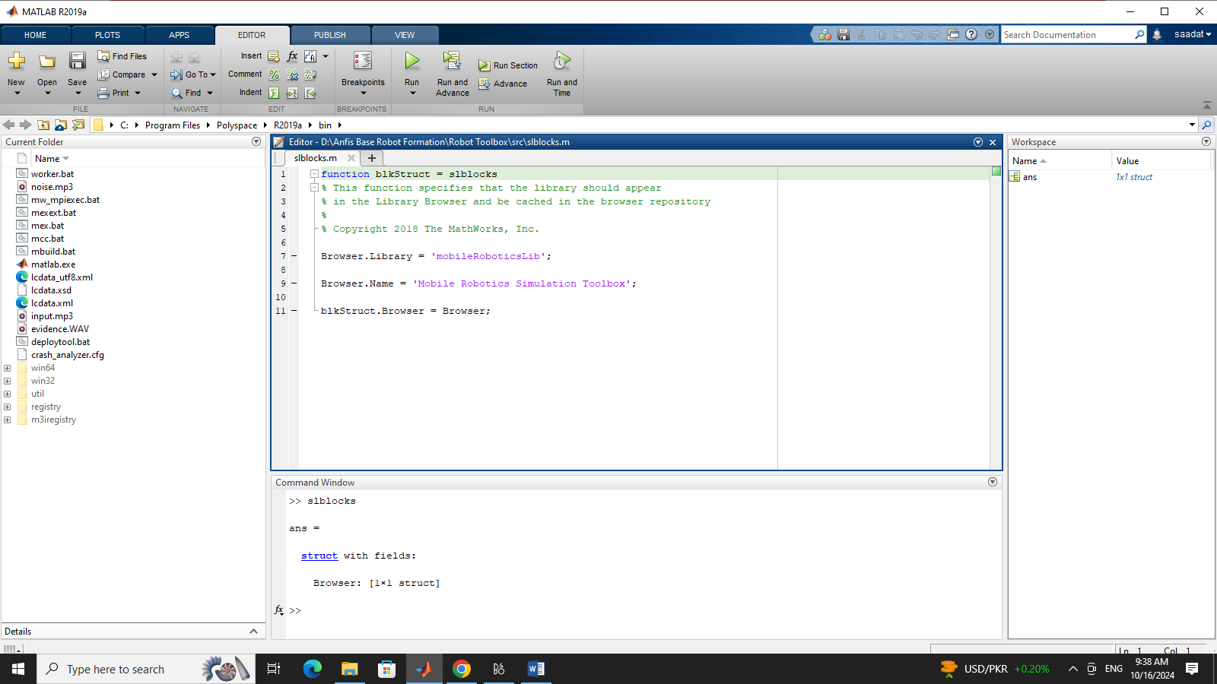
run it

step 3
Open start mobile robotics simulation toolbox.m file in Robot Toolbox
Make sure current folder in matlab should be same as which contain files
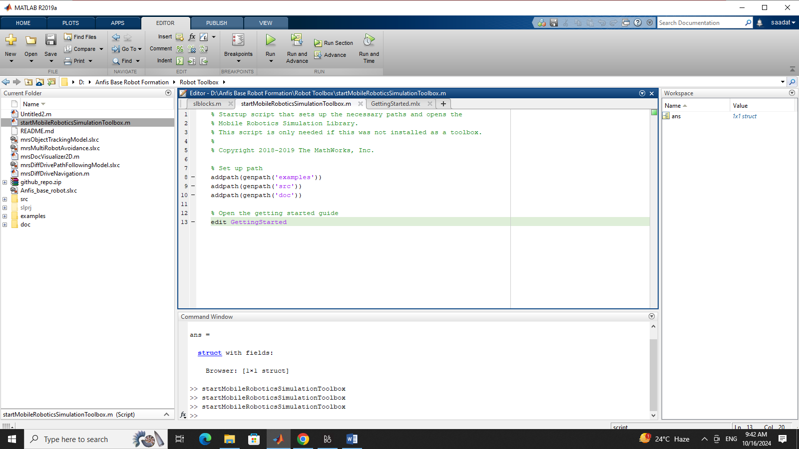

After running this a new mlx file with name getting started will open and it will have instructions means every this is ok

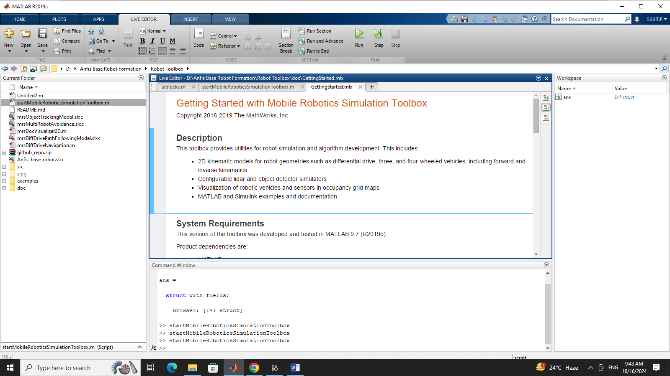

Step 4
Open workspace variable
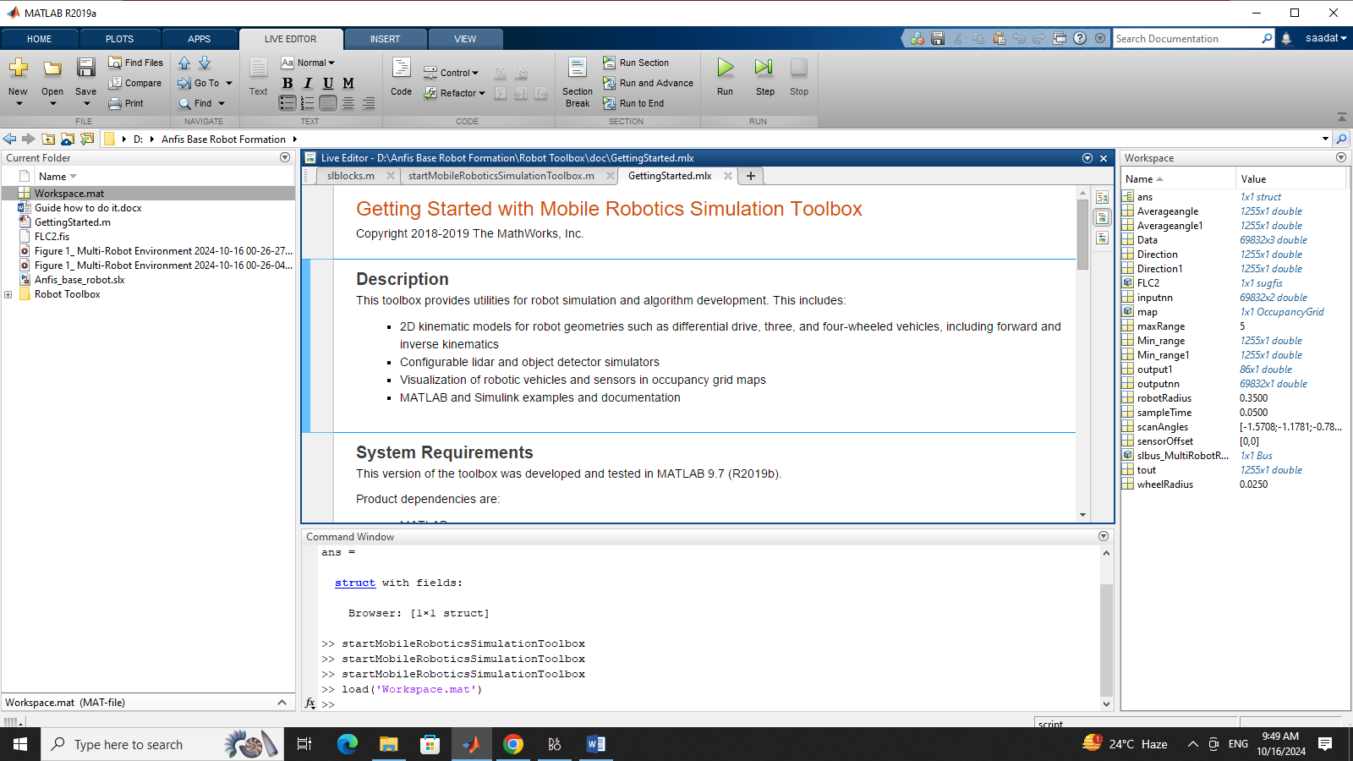

Step 5
Goto Simulink and open model Anfis base robot .slx

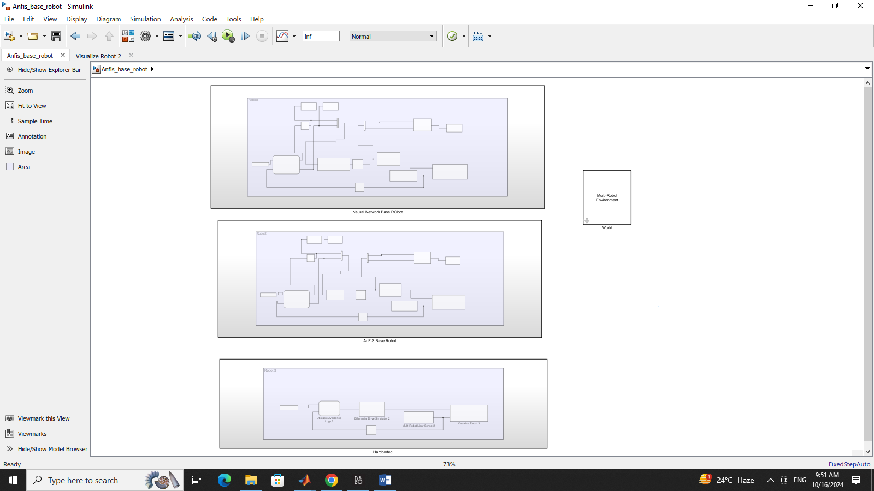

Now open library and refresh it and see if there is any mobile robotics toolbox

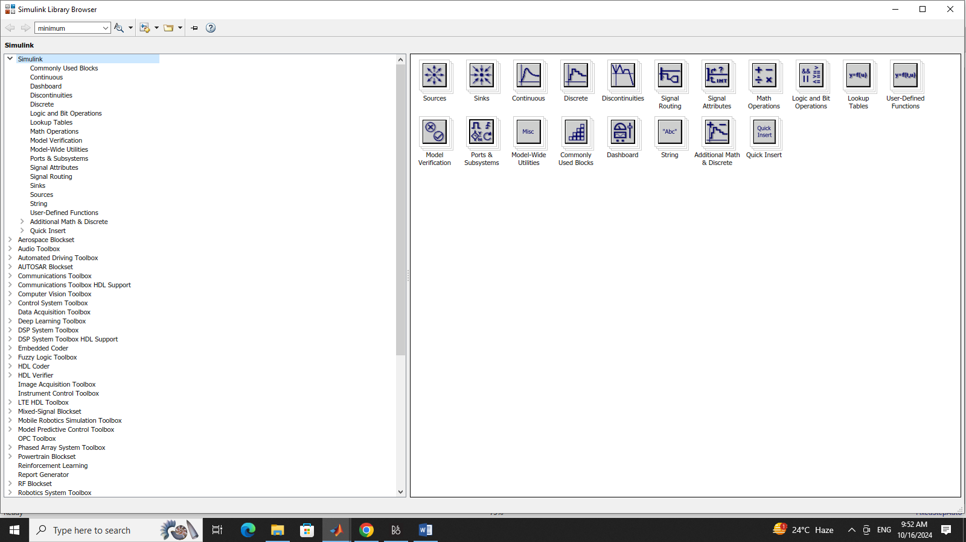
If so come back and run model
If not right click and select refresh
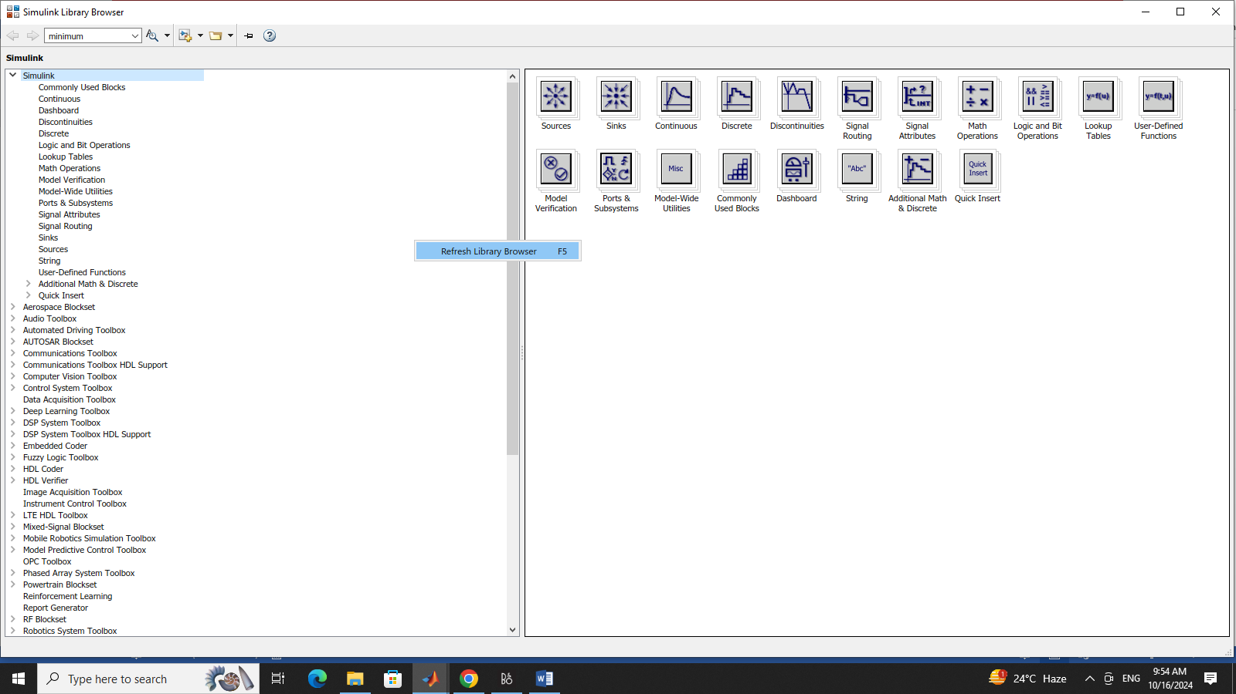

Step 6
Run the model
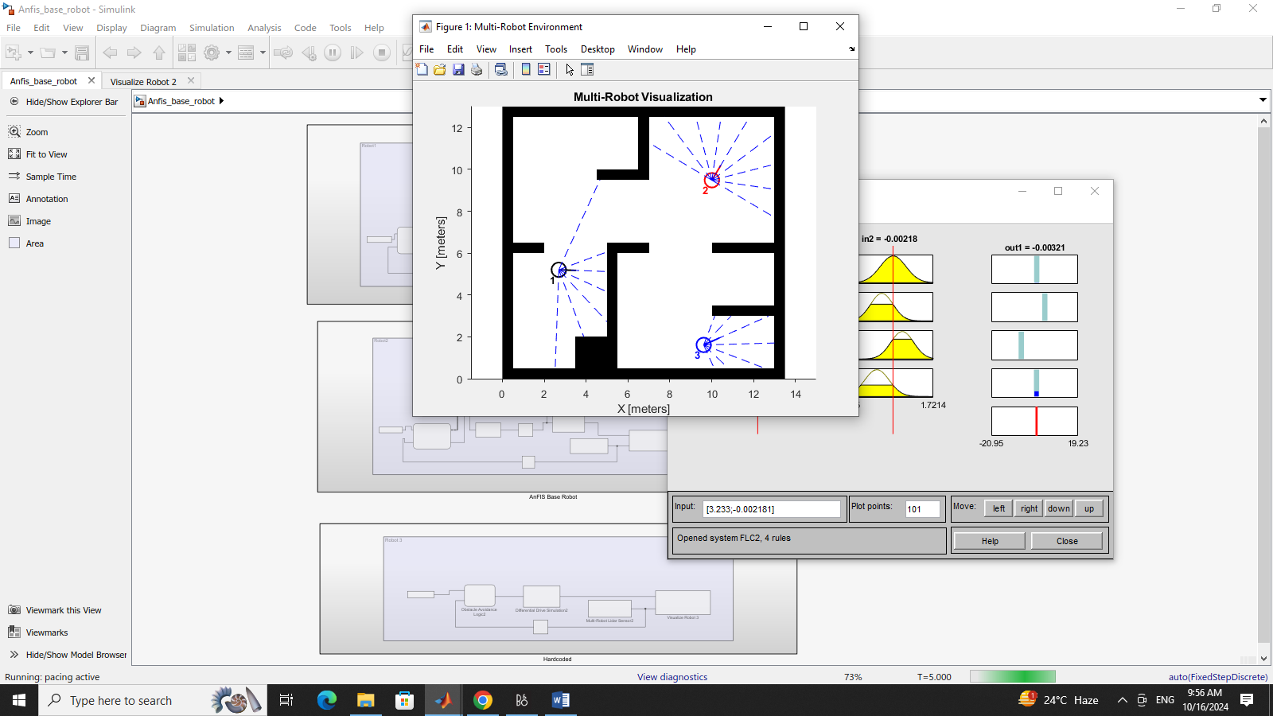

Model is working.

